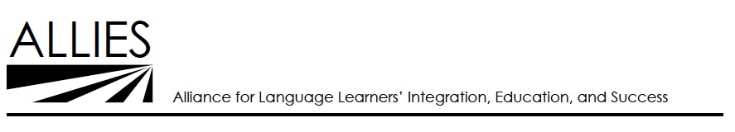

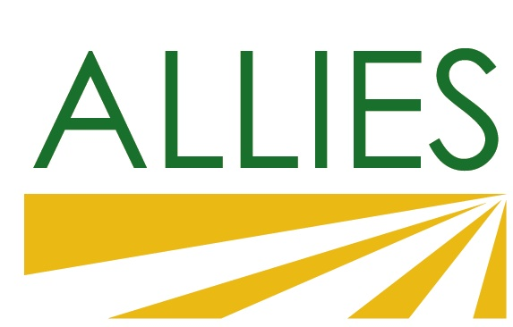

### ALLIES ESL Providers’ Network Meeting

*April 29, 2016, 12:30 p.m. – 3:30 p.m.*

East Side Adult School

### Meeting Summary

**Summary**

Approximately 60 ESL representing 26 community based organiations, adult schools and colleges.

**Policy Updates**

* New focus on reporting outcomes.
  + CBOs currently do this because they have been doing it for grants
* WIOA - New requiremetns for sharing funding and referrals with Workforve Development Boards. Lots of opportunity for referrals and new resources. Services might include tranporation, babysitting, and access to jobs. It does require students to have documentation.

**Consortium Updates**

South Bay Consortium

* No Wrong Door
* Lots of transitioning, first and foremost focus
* Workgroups formed
* Hiring learning disabled specialist
* 6 career pathways, but many lack skills to access
* Individual plans and transition specialists, with warm handoff

ACES

* Processing Center in downtown Gilroy, do assessment and referrals and literacy classes
* Meet and greet
* Career readiness, CTE program, nativagator
  + Phlebotomy (one class program)
  + Hospitality
* Highschool diploma program in Gilroy
* Contexutlized ESL for fields that are likely to be popular, especially for people without documentation
  + Computer applications
  + Landscaping
  + Eutrepuships
  + Childcare

ACCEL

* Agreeing on fundamental skills, mapping out what you need to thrive
  + Based on Minnesota Fast Track program
* Reopened adult school on the coast

North Santa Clara County Student Transitions

* Articulation and Curriculum groups taking the lead
  + Embedding soft skills and job search tools in ESL classes
  + Integrating placement testing
  + Meeting with different representatives, mapping out progression
  + Using lexile scoring to assess texts in adult schools and community colleges
* Student Support Group
  + Tools for identifying students with special needs

**Summary**

Paul and Louise Auerhan from Workshop Partnerships presented their plans for Immigration Integration.

* 3 stakeholders
  + ESL learners
  + Service providers
* What does success look like and metrics

**Summary**

* Accelerate Change
* Building Skills Partnership
* Campbell Adult Education
* Cañada College
* Catholic Charities
* De Anza College
* Gavilan College
* Grail Family Services
* Immigrantinfo.org
* Jefferson Adult Education
* Katharine & George Alexander Community Law Center
* Milpitas Adult Ed / San Jose City College
* Mission College
* Mountain View-Los Altos Adult Education
* Office of Immigrant Relations
* Palo Alto Adult School
* Redwood City 2020
* Refugee Transitions
* San Mateo adult school
* Santa Clara Adult Education
* Santa Clara County Library
* Sequoia Adult School
* Silicon Valley Adult Ed
* Silicon Valley Community Foundation
* Vision Literacy
* Working Partnerships USA