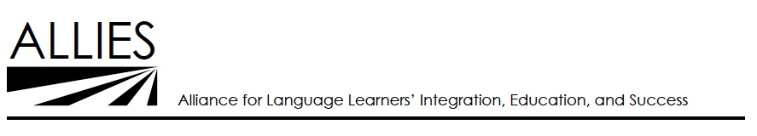

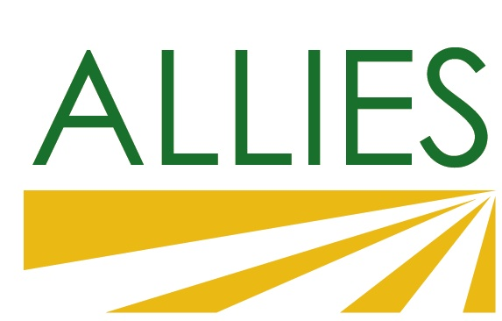

### ALLIES ESL Providers’ Network Meeting

### *April 29, 2016, 12:30 p.m. – 3:30 p.m.*

East Side Adult Education

Overfelt Adult Center, Building B

1901 Cunningham Ave, San Jose

### Agenda

**Outcomes**

* Practitioner sharing of innovations and developments
* Policy Updates
* Updates and input on ALLIES 2016 activities
  + Immigrant Integration Pathway
  + ALLIES strategic planning and staffing

|  |  |  |  |
| --- | --- | --- | --- |
| **12:30** | | **Lunch** |  |
| **1:00** | | **I. Welcome and Introduction** | Paul Downs, ALLIES |
|  | A. Meeting Purpose and Agenda | |  |
|  | B. Introductions  C. Announcements | |  |
| **1:10** | | **II. “EPN Shout Out” – Sharing of Innovations and Activities** | Participants |
| **1:30** | | **III. Regional and State Updates** |  |
|  | | A. Policy Updates |  |
|  | | B. Immigrant Integration Pathway |  |
|  | | C. Strategic Planning |  |
|  | | D. Input on Outside Presenters |  |
|  | | E. Mini-grants  F. Other |  |
| **2:00** | | **IV. Immigrant Integration Discussion Groups** |  |
| **3:00** | | **V. Share Outs** |  |
| **3:25** | | **VI. Summary and Next Steps** |  |
| **3:30** | | *Close* |  |