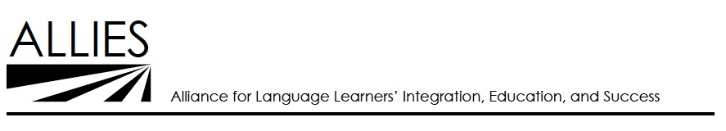

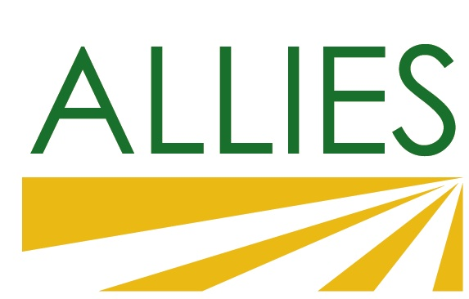

**ALLIES / AELA Joint Meeting**

***Learn About Mini-Grants for AB 86 Collaboration***

### *March 13, 2015, 12:30 p.m. – 3:30 p.m.*

Santa Clara Adult School,

1840 Benton Street, Santa Clara

**Outcomes**

* Participant networking and sharing of promising practices
* Ongoing relationship building between AELA and ALLIES
* Update on policy
* Refinement of the Mini-Grant and development of potential project ideas by participants
* Identify potential next EPN meeting dates

**Agenda**

|  |  |
| --- | --- |
| **12:30** | **Lunch** |
| **1:00** | 1. **Welcome** 2. Meeting Purpose / Agenda 3. Introduction 4. Overall Context (AB 86, SVA, AELA) 5. Immigration Update |
| **1:20** | 1. **Sharing of Local Initiatives and Activities** |
| **1:45** | 1. **Collaboration Mini-Grant** 2. Purpose and Overview 3. Examples of Collaboration 4. Questions of Clarification 5. Small Group Discussion |
| *2:45* | *Break* |
| **3:00** | 1. **Large Group Debrief** |
| **3:20** | 1. **Summary and Next Steps** |
| *3:30* | *Close Main Meeting* |